
Sec 1.1 – 1.4 -Analyzing Numerical Data
Test Name:
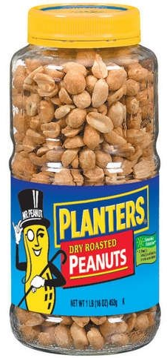
Practice Problems:
- The jar’s inner dimensions of the jar are approximately a cylinder with a height of 17 cm and a radius of 3.8 cm. The jar is completely filled to the top with large dry roasted peanuts.

What would be a good lower bound for the number of peanuts in the jar and why? SHOW YOUR WORK

What would be a good upper bound for the number of peanuts in the jar and why? SHOW YOUR WORK

A few students conducted a study of some solids and found the following container
(solid #1) held 52 peanuts

A few students conducted a study of some solids and found the following container (solid #2) held 69 peanuts.

5cm
4 cm
4 cm
12 cm
3 cm
3 cm

Fill out the following table: | Solid #1 | Solid #2
Volume
Number of Peanuts
Ratio

Using the information from the table what would be a good estimate for the number of peanuts in the jar?

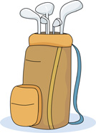
2. A person is purchasing a new golf club bag. The compartment for the golf balls is approximately the shape of a rectangular prism with the dimensions of 8 inches by 11 inches by 5 inches. Assuming golf balls are spherical with a 1.68 inch diameter, how many golf balls should fit in the compartment bag?
(Hint: Packing spheres in a rectangular prism usually take up 190% of the volume of the spheres using random packing.)
SHOW YOUR WORK

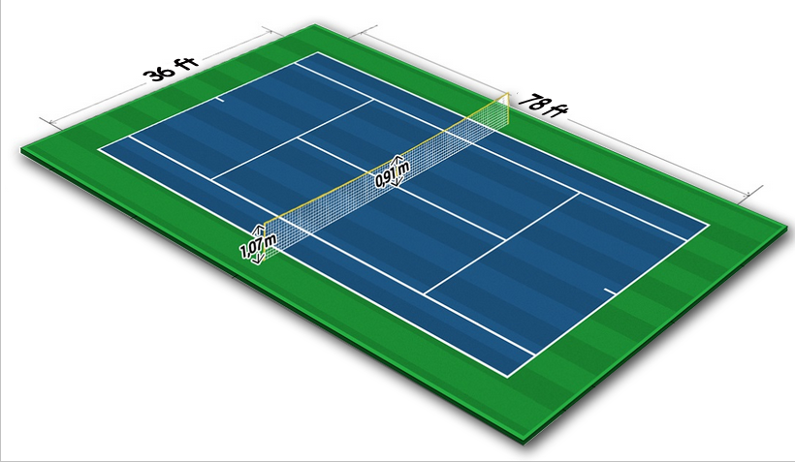
3. A tennis court is 36 feet long and 78 feet wide. How many people could fit on just the tennis court? (Remember the expected floor space a standing person occupies is about 2.5 sq feet)
SHOW YOUR WORK

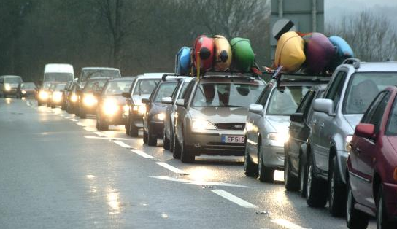
4. On a highway a wreck occurred and caused a 8 mile traffic jam on one side of the road. The average car is 13.5 feet in length and the average truck is 20 feet in length. 75% of the traffic jam consists of cars and 25% of trucks. If the average distance between vehicles is 3 feet, how many vehicles are stuck in the traffic jam?
SHOW YOUR WORK


5. What steps would you take to approximate the total amount Gwinnett County must pay teachers for the whole year?

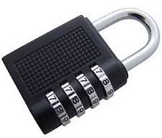
6. A suit case combination lock consists of a 4 digit code. Each digit can be any number 0 - 9. The only exception is that all four digits cannot be the same (e.g. the combination can’t be 1111, 2222, etc.) How many combinations are possible on a standard combination lock?
SHOW YOUR WORK


7. Aston University creates a 10 digit student number as the University enrolls each student. The first two characters must be a digit 1 through 9. The next seven characters can be anything and the last digit just can’t be the same as the ninth character (i.e. the previous digit). How many student numbers are possible? SHOW YOUR WORK


(BONUS) A person locked their android phone with a swipe code on a phone with a 3 by 3 grid block. Let’s consider an example where the swipe code must start with the middle button on the top row and must pass through two more buttons. Each consecutive button is adjacent (up, down, left, right, or diagonally). How many such swipe codes are possible?

8. The following are some common POSTER sizes.
(16 in. x 20 in.) (18 in. x 24 in.) (20 in. x 30 in.) (24 in. x 36 in.)

- What is the aspect ratio of each picture using the format (1:_______ )?

- If we decided to decrease the size of a (8 in. x 10 in.) photo so that the smaller side (the height) was decreased to 6 inches, what would the new wedth be? SHOW YOUR WORK

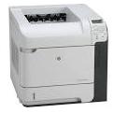
- Printing Costs
  - The 4015n printer that is used in most of the labs has a toner cartridge that costs $40.00 and each cartridge should print 10,000 pages. A ream of 500 pages for the printer costs $6.00. Just including those costs how much does it cost to print a single page?

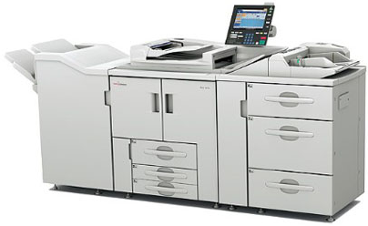
  - The toner cartridges for the Savin 907EX copy machine cost $120 and should copy 60,000 pages. There is also a maintenance charge of $150 for every 500,000 pages copied. A ream of 500 pages costs $5.00. Just including these costs how much does it cost to copy a single page?

- A student sketched some art on an 8 inch x 10 inch piece of paper. He wants to resize it to fit an 4 inch x 6 inch frame (as shown below)
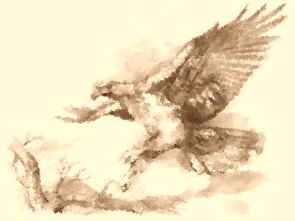
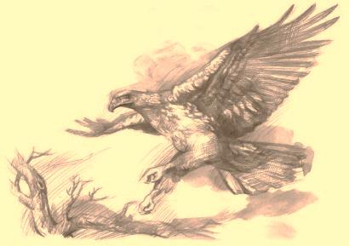
original sketch
10”
8”

x
4”

6”

reduced sketch size
with frame shown

What percent of the original sketch was still able to be included in the frame?

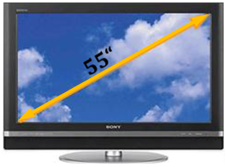
- Televisions and monitors come in two common aspect ratios, 4:3 and 16:9 (sometimes 16:10 is also used). A 42 inch TV suggests that the main diagonal of the TV is 42 inches. Determine the dimensions of the screen of a 42 inch TV with a 4:3 aspect ratio.
42 inches

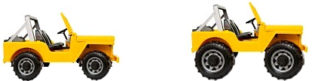
- Ron recently increased the size of his Jeep tires from the original P220/75R16 to the larger P250/85R17. If Mike didn’t recalibrate his speedometer, how fast is he really going on the new tires when his speedometer shows he is traveling 60 mph?

  - If your odometer suggests that Ron drove 2000 miles based on the original size tires, how far did he actually travel on the new tires? SHOW YOUR WORK

  - If his speedometer suggests that he is traveling at 60 mph based on the original size tires, how fast is he actually traveling on the new tires? SHOW YOUR WORK

Consider the grading systems
Mr. Winking’s Grade Weighting
Homework Average | 10%
Quiz Average | 25%
Test Average | 45%
Final Exam Grade | 20%
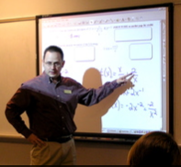

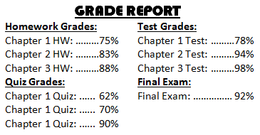
- If you had the following grades shown in the report at the right, determine what your grade would be in Mr. Winking’s Class.

- If you had the following grade report shown below but hadn’t taken your final exam yet, what would your grade be going in to the final exam?

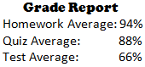

- If you had the following grade report but hadn’t taken your final exam yet, what would you need to make on the final exam to score at least a 70 in the overall course?

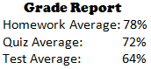

Calculate the Flesch–Kincaid Grade Level Index (FKGLI) using the following formula:

Gettysburg Address (excerpt)
Four score and seven years ago our fathers brought forth on this continent, a new nation, conceived in Liberty, and dedicated to the proposition that all men are created equal.
Now we are engaged in a great civil war, testing whether that nation, or any nation so conceived and so dedicated, can long endure.
We are met on a great battle-field of that war.
We have come to dedicate a portion of that field, as a final resting place for those who here gave their lives that that nation might live.
- Find the Flesch-Kincaid Grade Level Index of the excerpt of the Gettysburg Address.

- Determine the check digit (d) for the UPC bar code number 2-81273-05213-d

- Determine the check digit (d) for the UPC bar code number 5-61812-10624-d.

- What is the check digit (d) for the VISA card number 4364 2813 2705 018d?

- Given the check digit is 3, find the missing number X for the Mater card number 5164 2X13 2705 0183?

p.5

